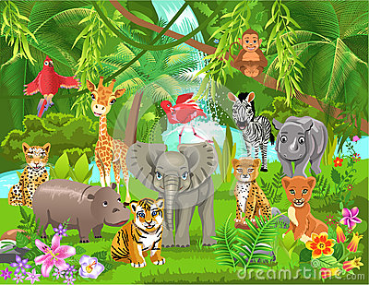
Hello Parents!
It’s a jungle in here! We have been having a lot of fun learning about all the sounds and colors of the jungle! We’re roaring, slithering, stomping, and flapping all day long! If you have any books your child would like to share, please feel free to bring them in. (They do not have to be theme related, but that is definitely helpful!)
A few reminders:
Please continue to send in a winter bag with hat, mittens, snow pants and boots every day. We go outside daily as long as the temp stays above 20 degrees.
PLEASE take your child’s snow gear home daily. It needs to be dried for the next day.
Also, please label all items that you send to school with your child’s name. We want to be sure your things gets back to you!
Also, please give us a call us at 672-1949 and let us know if your child is going to be absent. We miss your child of they aren’t here!
As always, if you have any questions please feel free to email me at earlylearners352@gmail.com

Thank you so much!
~Mrs. Rubin and the Early Learner Team

