The Preschool Journal
November 18, 2019 Volume V
Dear Students and Families!

Can you believe that November is more than half over! We have been so busy learning all about the different versions of The Little Red Hen. Make sure you visit Parent Pages to see your child’s favorite version and why they love it.

This month we made pumpkin bread, cut and threshed some wheat, we even painted with real wheat.
We made play DOUGH and used real pans to make bread, pies and cupcakes.

For the rest of the month we will be talking about Old Mother Hubbard (& Old Mister Hubbard) and their poor dog. We will be building with recycled boxes, cups and cans. So much to do and so little time until Thanksgiving break.

Don’t Forget! Our recipes for your Preschool Family Cookbook are due this Friday. This will give me enough time to turn the recopies into a book for the children to take home to show their family over the holiday!

Warmest Regards,
Mrs. Larabee, Ms. Jamie & Ms. Jen

Important Dates!

November 22nd
Recipes are due for our class Cookbook.

November 27th
Extended Day only

November 28th & 29th
ELCM closed for Thanksgiving! Have a safe and Happy Holiday!

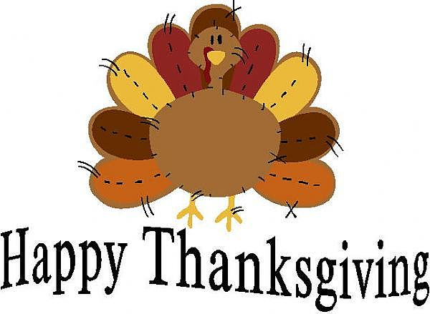
Please send your child with warm hats, mittens and coats for the cold weather

Sharpie markers are available near the sign in book. Please make sure all of your child’s items are labeled with their names.

