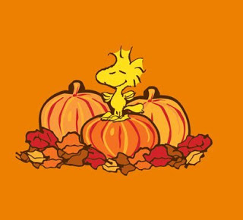

PRESCHOOL OCTOBER 2019 SNACK SCHEDULE

MONDAY TUESDAY WEDNESDAY THURSDAY FRIDAY
Sept.30  FOSTER | 1  SIMEON | 2  DYLAN | 3  KAYLEE | 4  MADDIE
7  BIANCA | 8  WILLIAM | 9  C.C. | 10  DAVI | 11  EMMETT
14  COLUMBUS DAY  EXTENDED ONLY | 15  NAOMI | 16  ARIA | 17  MRS.ERB | 18  EMMERICH
21  TREVOR | 22  DAVI | 23  OWEN | 24  WILLIAM | 25  C,C,
28  BIANCA | 29  KAYLEE | 30  MADDIE | 31  Halloween Party | Nov. 1  Halloween Party

Please include a Healthy Snack and Drink for 12 Children on each day. Birthday Snacks can be a Sweet Treat of your choice. *Please have your child wear Orange or Black for the Halloween Parties. No costumes please. Thank you!

