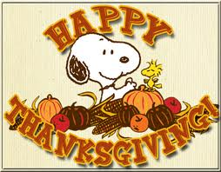

November 19, 2019
Dear Parents,
There is a chill in the air and excitement is mounting for the upcoming Thanksgiving Break. Our class has really enjoyed all the travel opportunities in our ELCM Airport and the Erb Express Train Station. They have travelled all around and had great adventures. Please take a moment to check out all the beautiful artwork in our classroom and the Plump and Perky Turkeys in our front hall.
Here are a few important reminders:
- Please make sure you send your child in to school with winter coat, hat, and mittens that they can put on themselves for our chilly early morning recess. We are working very hard to help them be independent when getting ready to go out so please encourage them to do it themselves at home also Make sure all their winter clothes are labelled so we can help them keep track of their things.
- Show & Tell will begin on Monday December 2. The Snack Child is asked to bring in 1 favorite item from home to share during morning meeting. It is important that it can fit into their cubby. They will tell us all about it and then answer questions from their friends. This is a wonderful confidence boosting activity that helps with speech and language and lets us develop that Home/School Connection.
- ELCM Thanksgiving Holiday Schedule is:
Extended Care Only on Wed. 11/27
Closed on Thurs. 11/28 and Fri. 11/29
- Parent / Teacher Conferences will be scheduled during the week of December 9 and a Sign-up sheet will be posted in the hall by the cubbies the week before. This is basically a 15-20-minute meeting to share your child’s progress. This is for parents only.

Thank you so much for sharing your family with us.

Linda Erb & Laurie Curless

