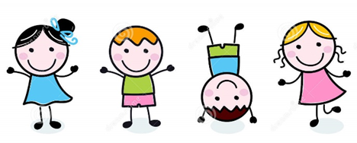
Dear Families-
We were very busy in the month of October. We started the month by exploring woodland creatures. We made all different kinds of creatures. Some of our favorites were the fox, the bear and the owl. We loved wearing masks and ears that looked like those animals. We also had fun dancing around to “We Are Going on a Bear Hunt”. Don’t worry the children were not scared!! We also had fun exploring acorns and wood inside of the sensory bin. The children had fun filling scoops with acorns and dumping them back out again
. 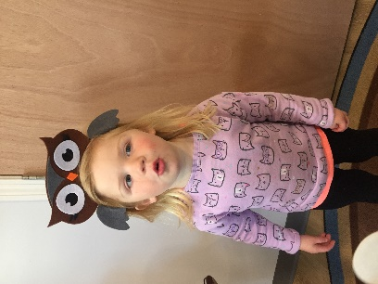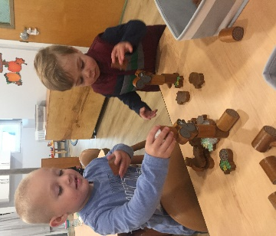
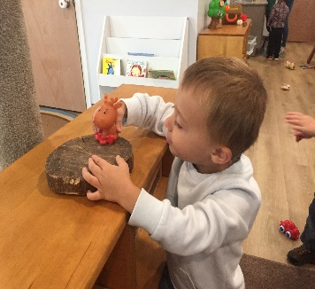
Our next adventure was making ourselves into a scarecrow. Outside the children got to fill their clothing with hay. They worked hard at filling their shirts and pants. They also had fun exploring with the hay. Filling their construction trucks with hay and throwing the hay up in the air was lots of fun too! Everyone loved when we read, “There Was An Old Lady Who Swallowed Some Leaves”.
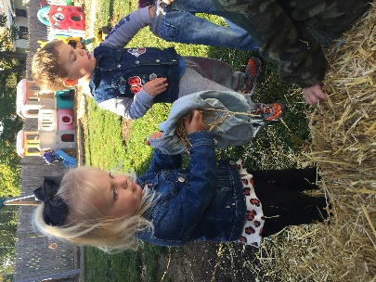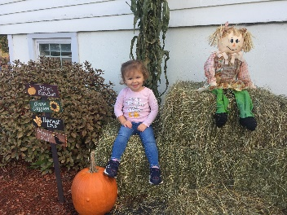
As the month rolled to an end, we began exploring with pumpkins. We talked about who has pumpkins at their house and what color they are. Playing in our pretend pumpkin stand we got to see how much our pumpkins weighed with a scale. We enjoyed reading, “We Are Going on a Pumpkin Hunt”.
Making pumpkin art with orange paint and was exciting for all, and the children loved making all kinds of different shapes with stencils and cutting with our cutters using pumpkin play-dough.
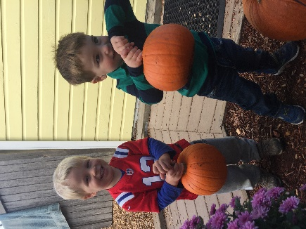 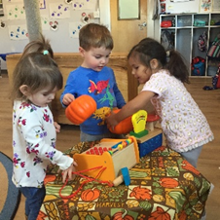
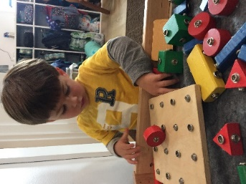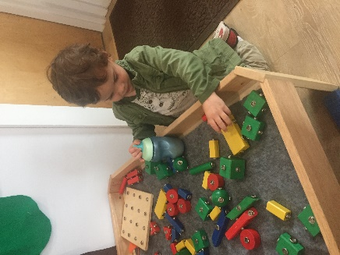
Reminders
As it gets colder please remember to bring in weather appropriate clothing and label everything. Our Early Learners are learning how to put their own belongings away so some items may be displaced
Please remember to bring everything home at the end of the week so teachers are able to clean and prepare for the following week
Thanks-
Ms. Laura and Ms. Allison

