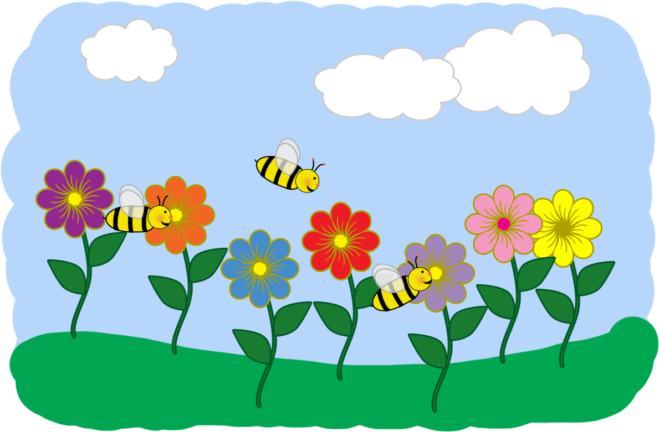

Hello Parents!
I feel like it rained for SO long! The sun is starting to shine on a regular basis, and the temperatures are rising! Pretty soon it will be Summer... but for now, Spring has Sprung! The rain, the sun, the flowers, the bugs... it’s ALL exciting to us!
The Early Learners have been having so much fun exploring bugs, plants, and all things Spring!
Our favorite books so far are The Happy Bee by Ian Beck and When Spring Comes by Kevin Henkes. Do you have a favorite book about Spring or bugs? Please feel free to share! We share a lot of Eric Carle books during this theme. The artwork is great, and our little ones LOVE to be turned in to bugs!
Happy Mud Season!
Also, the sun is getting stronger! If your child stays for extended day and you would like us to slather them up for the afternoon, please provide us with sunscreen and fill out our sunscreen authorization form which can be found on the website, or we have hard copies available if you prefer.
Thank you!
~Mrs Rubin

