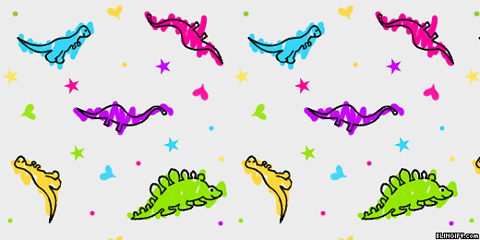
Hello Parents!
January has been SO much fun! We are stomping, roaring, and dancing our way through our dinosaur theme. It’s one of the most popular themes year after year!
Laurie Berkner’s ‘We Are the Dinosaurs’ is on repeat in our classroom. It’s so fun to act out the words!
A few reminders:
Please send a separate bag with hat, mittens, snow pants and boots every day. We try to go outside daily as long as the temp stays above 20 degrees.
Feel free to leave your childs snow gear in the classroom unless you need it at home in between school days. Otherwise, just be sure to take it home at the end of the week.
Also, label all items that you send to school with your child’s name. Some of our friends like to put their things in someone else’s cubby and we want to be sure your things gets back to you!
Please give us a call us at 672-1949 and let us know if your child is going to be absent. We miss your child of they aren’t here!
As always, if you have any questions please feel free to email me or call the school.

Thank you so much!
~Mrs. Rubin

