Early Learner ONE Schedule 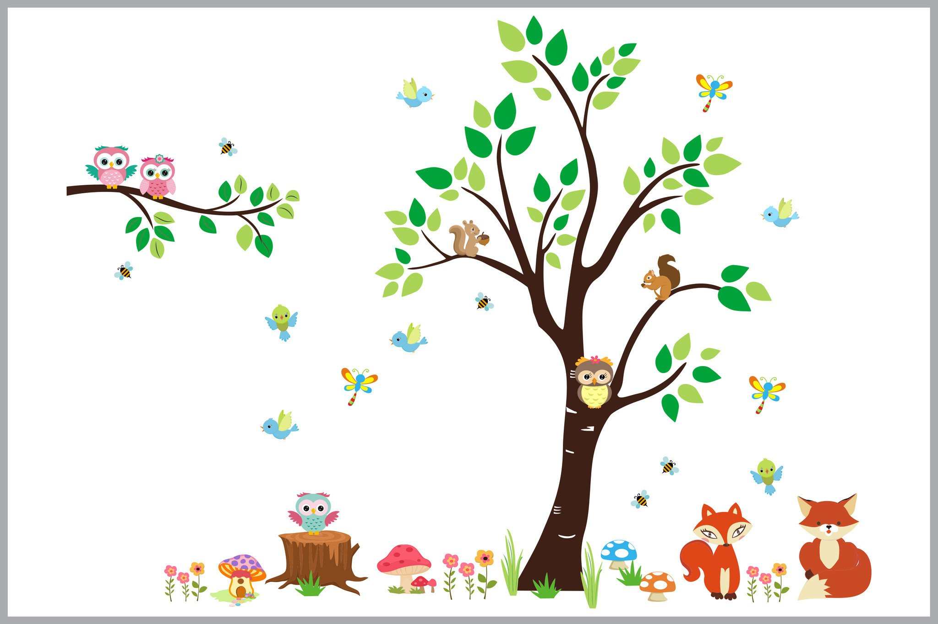
Classroom Free Play: 7:00 – 8:45
Early morning time is spent exploring the classroom through play while we wait for our friends to arrive.
Snack: 8:45 - 9:15
The children take turns washing hands, and then sit down together. This is a great time for social interaction while enjoying a nutritious snack.
Morning Meeting: 9:15 - 9:30
During Morning Meeting we gather as a whole group to say hello to our teachers and friends. It is also our time to share a story and sing our favorite songs.

Music and Movement: 9:30 - 9:45
A fun and active transition time as we learn and play through dance, instruments and kid’s yoga.

Recess: 9:45 – 10:30
This is our time to get outside and PLAY! We will explore our playground, and engage in fun gross motor activities.
Theme Time: 10:30 – 11:15
During this time we explore and learn through art and themed activities. We learn and grow and enjoy one another through play.

Goodbye Meeting: 11:15 - 11:30
At this time we gather to end our morning and say goodbye to our part-time friends.
Lunch: 11:30 - 12:00
The children take turns washing hands, and enjoy the social setting of lunchtime.

Rest Time: 12:00 - 2:30
This is a quiet time to rest minds and bodies, and get ready for the afternoon. Children who wake earlier than 2:30 will be offered a quiet activity while they wait for their friends to finish resting.

Afternoon Snack: 2:30 - 3:00
Once rest is over, the children wash hands and sit together for a nutritious snack.

Outside Play: 3:00 - 4:30
The children have fun developing gross motor skills through play with balls, bubbles, ride on toys, toy vehicles, parachutes, etc.

Free Play/Classroom Exploration/Outside Play: 4:30 - 6:00
We finish the school day with the children by playing in our Centers, doing an art activity, or playing outside.

