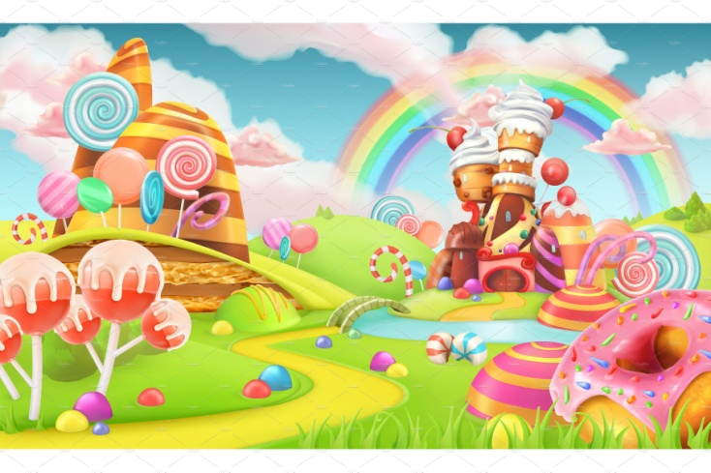

Hello Parents!
It’s almost CHRISTMAS? Where has the time gone? December has been a month full of shapes and colors! We have been having a ton of fun learning about the shapes in our everyday life – and the colors that surround us.
Just a few reminders:
Please send a separate bag with hat, mittens, snow pants (if there is snow), and boots (again... if there’s snow ) every day. We go outside daily as long as the temp stays above 20 degrees.
Please label all items that you send to school with your childs name. We have a few friends that like to empty their backpacks {our stuff is FUN! ) and we want to be sure your things gets back to you!
Also, please give us a call us at 672-1949 and let us know if your child is going to be absent. We miss your child of they aren’t here!
As always, if you have any questions please feel free to email me at earlylearners352@gmail.com

Thank you so much!
~Mrs. Rubin and the Early Learner Team

