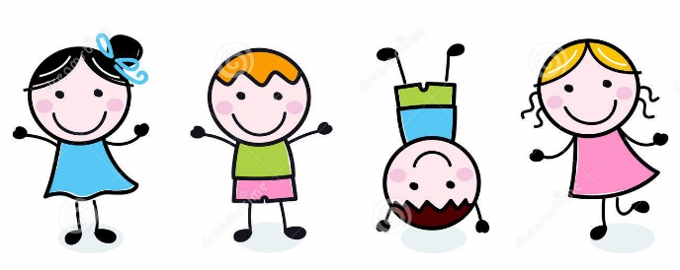Early Learner Daily Schedule

Classroom Free Play: 7:00 - 9:15
Our early morning time is spent exploring the classroom through play, and enjoying time outside.

Morning Meeting: 9:15 - 9:30
During Morning Meeting we gather as a whole group to say hello to our teachers and friends. It is also our time to share in a thematic story and sing our favorite songs.

Morning Snack: 9:30 - 9:45
The children take turns washing hands, and then sit down together for a whole group snack. This is a great time for social interaction while enjoying a nutritious snack.

Theme Time: 9:45 – 10:45
During our Theme Time the children and teachers are divided into small groups. These small groups rotate through art, dance, instruments, kid’s yoga and thematic activities.

Outside Play: 10:45 - 11:30
The children explore outdoor activities on woodchips, sand and grass.
Goodbye Meeting: 11:30 - 11:45
At this time we gather to end our morning, and say goodbye to our part-time friends. Our full-day friends share in a lunch time story.
Lunch: 11:45 - 12:30
The children take turns washing hands, and then enjoy the social setting of lunchtime.

Rest Time: 12:30- 2:30
This is a quiet time to rest minds and bodies, and get ready for the afternoon. Children who wake earlier than 2:30 will be offered a quiet tabletop activity while they wait for their friends to finish resting.

Afternoon Meeting: 2:30 - 3:00
Once rest is over, the children gather for an afternoon story, music and movement and kids yoga.

Afternoon Snack: 3:00 - 3:30
The children take turns washing hands, and then sit down together for a whole group snack.

Outside Play: 3:30 - 4:30
The children have fun developing gross motor skills through play with balls, bubbles, ride on toys, toy vehicles, parachutes, etc.

Free Play/Theme Activity/ Outside Play: 4:30 - 6:00
We finish the school day with the children by playing in our Centers, doing an art activity, or playing outside (weather permitting).

