Baxter the Big Black Bear

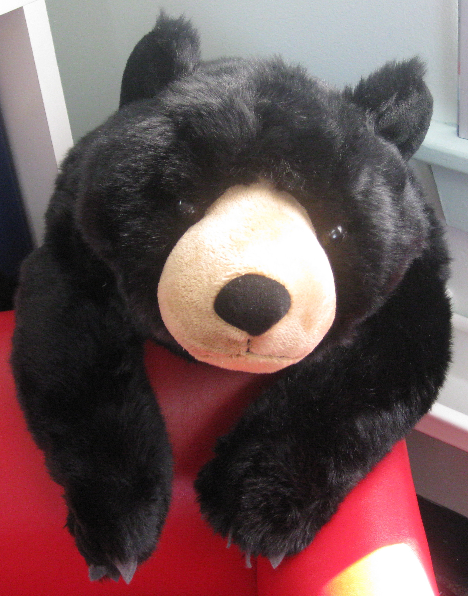

You will soon be meeting our traveling bear. His name is Baxter, the Big Black Bear. Beginning Friday, January 18th, Baxter will begin to travel home with each child for an awesome adventure. Adventures are simple in the sense that just visiting your home is an adventure unto itself☺.

Enclosed with this letter is the travel schedule for Baxter. I hope the scheduled date works well for you and for your child.

Baxter will be sent home in his own tote bag. He will be equipped with bear stories to read with your child, a backpack containing markers, and a large piece of white poster board. On the poster board there will be a story starter for your child to finish. It will read as follows:
__________’s Adventure with Baxter

With your help, your child’s “homework” will be to create a poster depicting the highlights of Baxter’s visit to your home. Photos with captions, and hand drawn pictures along with a story, are both great ideas for the poster. After your child has shared his/her poster with the class, I will proudly display it in our classroom, and then the poster will be yours to keep. Be as creative as you like with this project, and have fun with it! ☺

Thanks, in advance for your help and support with this fun activity, and be sure to share this letter with your child!

PS: If Baxter is sent home on a Friday, he must be returned by the following Friday, as the next scheduled child will be waiting to take Baxter home!

Baxter’s Traveling Schedule

Date: Child:

Friday, January 18 Caleb

Friday, January 25 Frankie

Friday, February 1 Curtis

Friday, February 8 Amelia

Friday, February 15 Bennett

Friday, February 22 Abigail & Emily

Friday, March 8 Arianna

Friday, March 15 Dominik

Friday, March 22 Tucker

Friday, March 29 Reid

Friday, April 5 Hailey

Friday, April 12 Lucas

Friday, April 19 Ellamina

