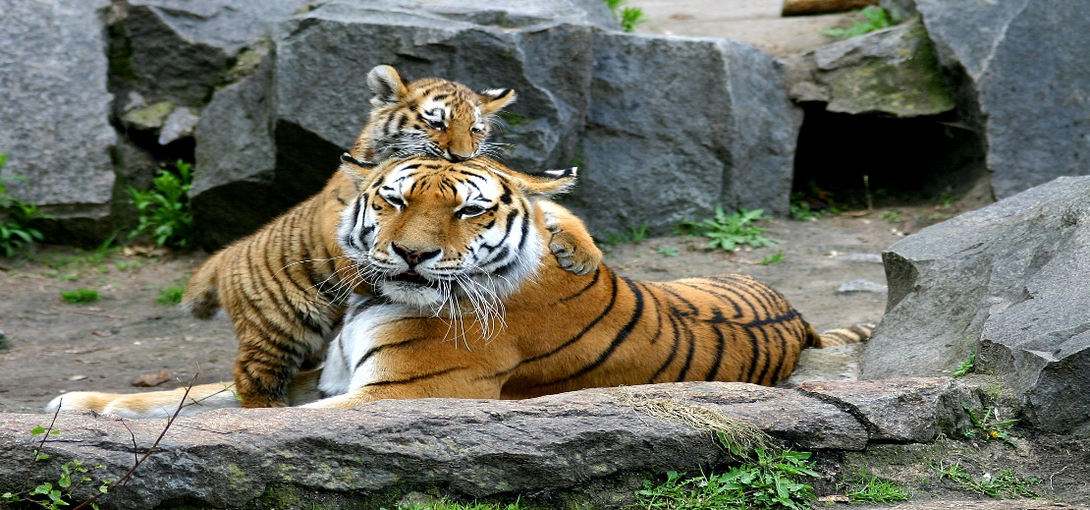

April 15, 2019
Dear Parents,
Elephants and Tigers and Zebras, Oh My! It is a Jungle in Preschool right now and we are all loving it. Not only did our friends paint and make a Jungle Jeep but they have also earned their Preschool Jungle Jeep Licenses. We are going on all kinds of adventures in our Jeep and trying to find “Patterns” in the Jungle. Please check out our Tiger/Zebra Patterns in our room.
Here are a few reminders:
- Please continue to send in coat, hats and mittens as we have the early recess at 9:00 am and it tends to be chilly then.
- Please continue to send in water bottles as they will bring them outside for their afternoon recess and can use them in the classroom throughout our day.
- Spring Break is next week 4/22- 4/26. ELCM will be open for Extended Care students only.
- We will have a Surprise Theme for the first week back from vacation and then we will launch into our “Ocean” Unit to finish out our year.
- The Parent / Teacher Conference Sign-up will be posted by the cubbies at the end of this week.

Imagination is the foundation of all learning

Linda Erb & Laurie Curless

