PRE-K SNACK CALENDAR
May/June
Sun | Mon | Tue | Wed | Thu | Fri | Sat
5 | 6 | 7 | 8 | 9 | 10 | 11
 | LANDEN | TRACE | DANNY | LILLY | PAIGE
12 | 13 | 14 | 15 | 16 | 17 | 18
 | LEAH | JUNIOR | MIA | MCKENNA | MCKAYLA
19 | 20 | 21 | 22 | 23 | 24 | 25
 | HAYLEE | EVELYN | MCKENNA | BRADY | DRAVEN
26 | 27 | 28  SAM | 29  TANISHA | 31  Friendly Farm  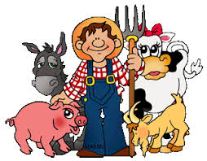 | 31  VICTOR | 1
2 | 3 | 4 | 5  Teacher’s  Surprise  Snack | 6  Teacher’s  Surprise  Snack | 7 | 8

Show & Tell: Children’s Choice - The children may bring whatever they would like to share from home

Birthday Bash: We will be celebrating our summer birthdays: (MWF) Danny ~ Paige ~ Leah ~ Mia
(T/TH) Lilly ~ Leah ~ Mia ~ Mckenna

