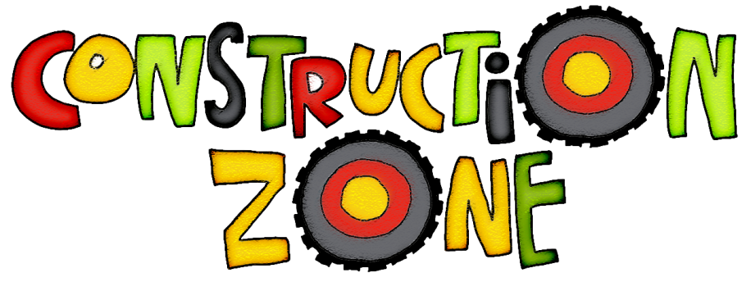
April 2019

Hello Early Learner Parents!
Our Construction theme is well under way, and we are having a BLAST! What’s better than whacking things with hammers and pretending to drive great big diggers?! This theme even translates well to our playground where we can dig, dump, and flatten all morning long!
The nicer weather is upon us, and we will be spending the majority of our time outside on these beautiful days! Please be sure to have appropriate clothing for outside play. Layers are best during this time of year, as it can go from warm and sunny to breezy cool and cloudy in the blink of an eye!
As always, if you have a book from home that your child would like to share with us, please feel free to do so!
Thanks so much!
~ Mrs. Rubin and the Early Learner Team

