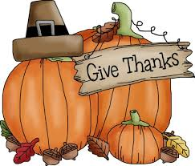 PRE-K Thanksgiving Celebration

In the month of November we are celebrating family!

In celebration of our Pre-K family, we will be sharing an “early lunch” with Mrs. Kaylee’s &
Ms. Hannah’s class on Monday, November 25th, and Tuesday, November 26th.

Your child does not need to bring a lunch to school on either day.

This is our schedule…

Monday, November 25th - 11:30-12:30: 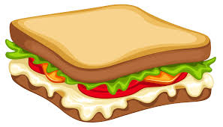 & & 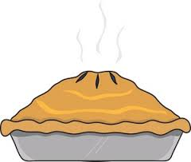

Our Pre-K classes will join together for a “Family Sharing” lunch.
We are asking every child to bring a “favorite” item to share at our luncheon. We have divided the food into categories such as favorite fruit, vegetable, heat-up, sandwich, chip/cracker, dessert and beverage. Each item will need to serve 28, but we only need the portion to be “bite-size”. For example, a favorite sandwich can be cut into 6 pieces, or a hot item only needs to provide 24 tablespoons. Portions will be small and food will be at a maximum variety.
This lunch will have a very special meaning as it is being sent with love from home.
The sign-up for our “Family Sharing” lunch is posted on our Parent Board.

Tuesday, November 26th - 11:30-12:30: 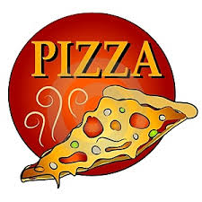

Our Pre-K classes will join together for a pizza lunch.
Mrs. Kaylee’s & Mrs. Harrigan’s T/TH classes will provide the drink and dessert, and ELCM will provide the pizza. If your child does not like pizza, please send in and alternative main meal.

