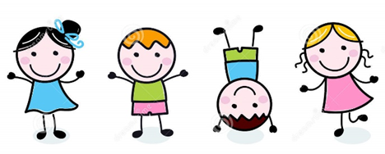
Dear Families-
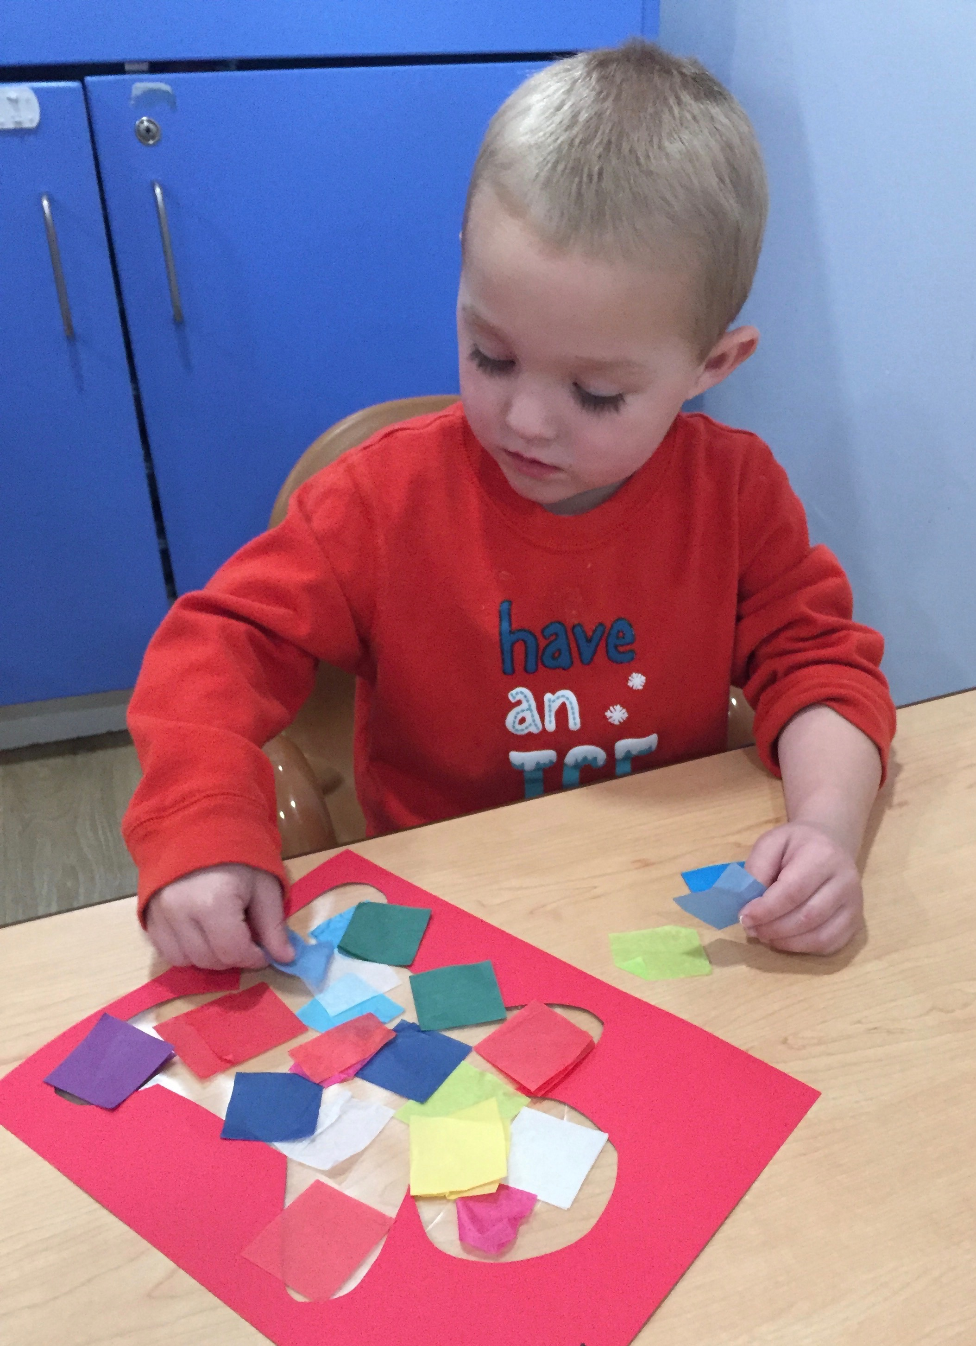
December was such a busy and exciting month for the Early Learners as they explored “Candy Land”. The focus was on learning our shapes and colors. Dancing to The Shape Song Swing Along book and singing the “Rainbow Song “ were two of their favorites. Exploring the different colors through our holiday crafts made learning fun!
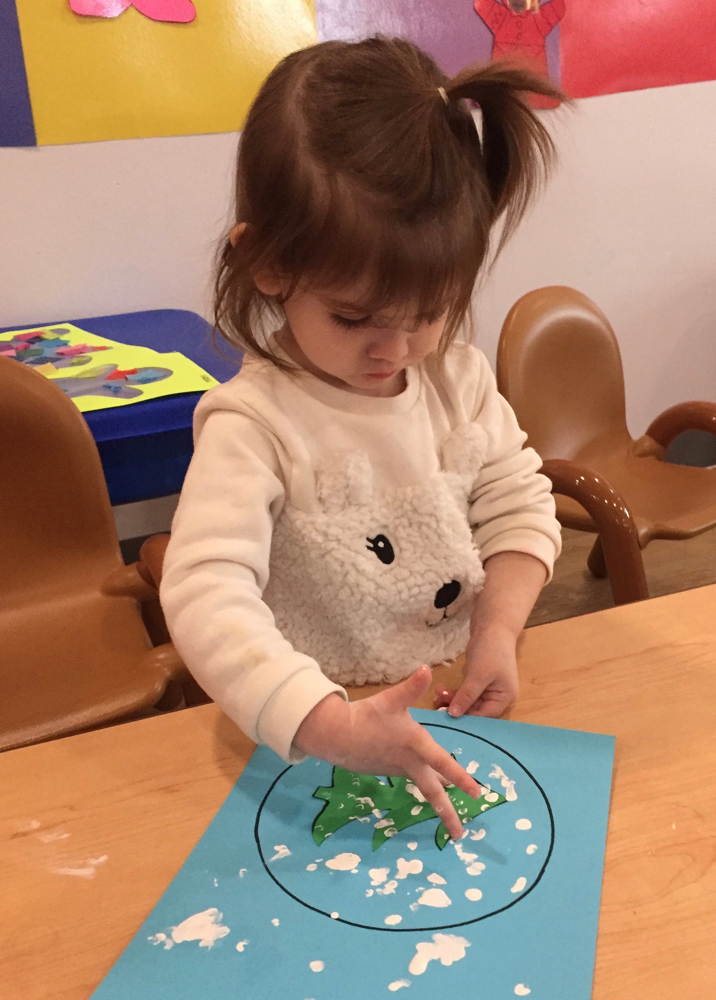
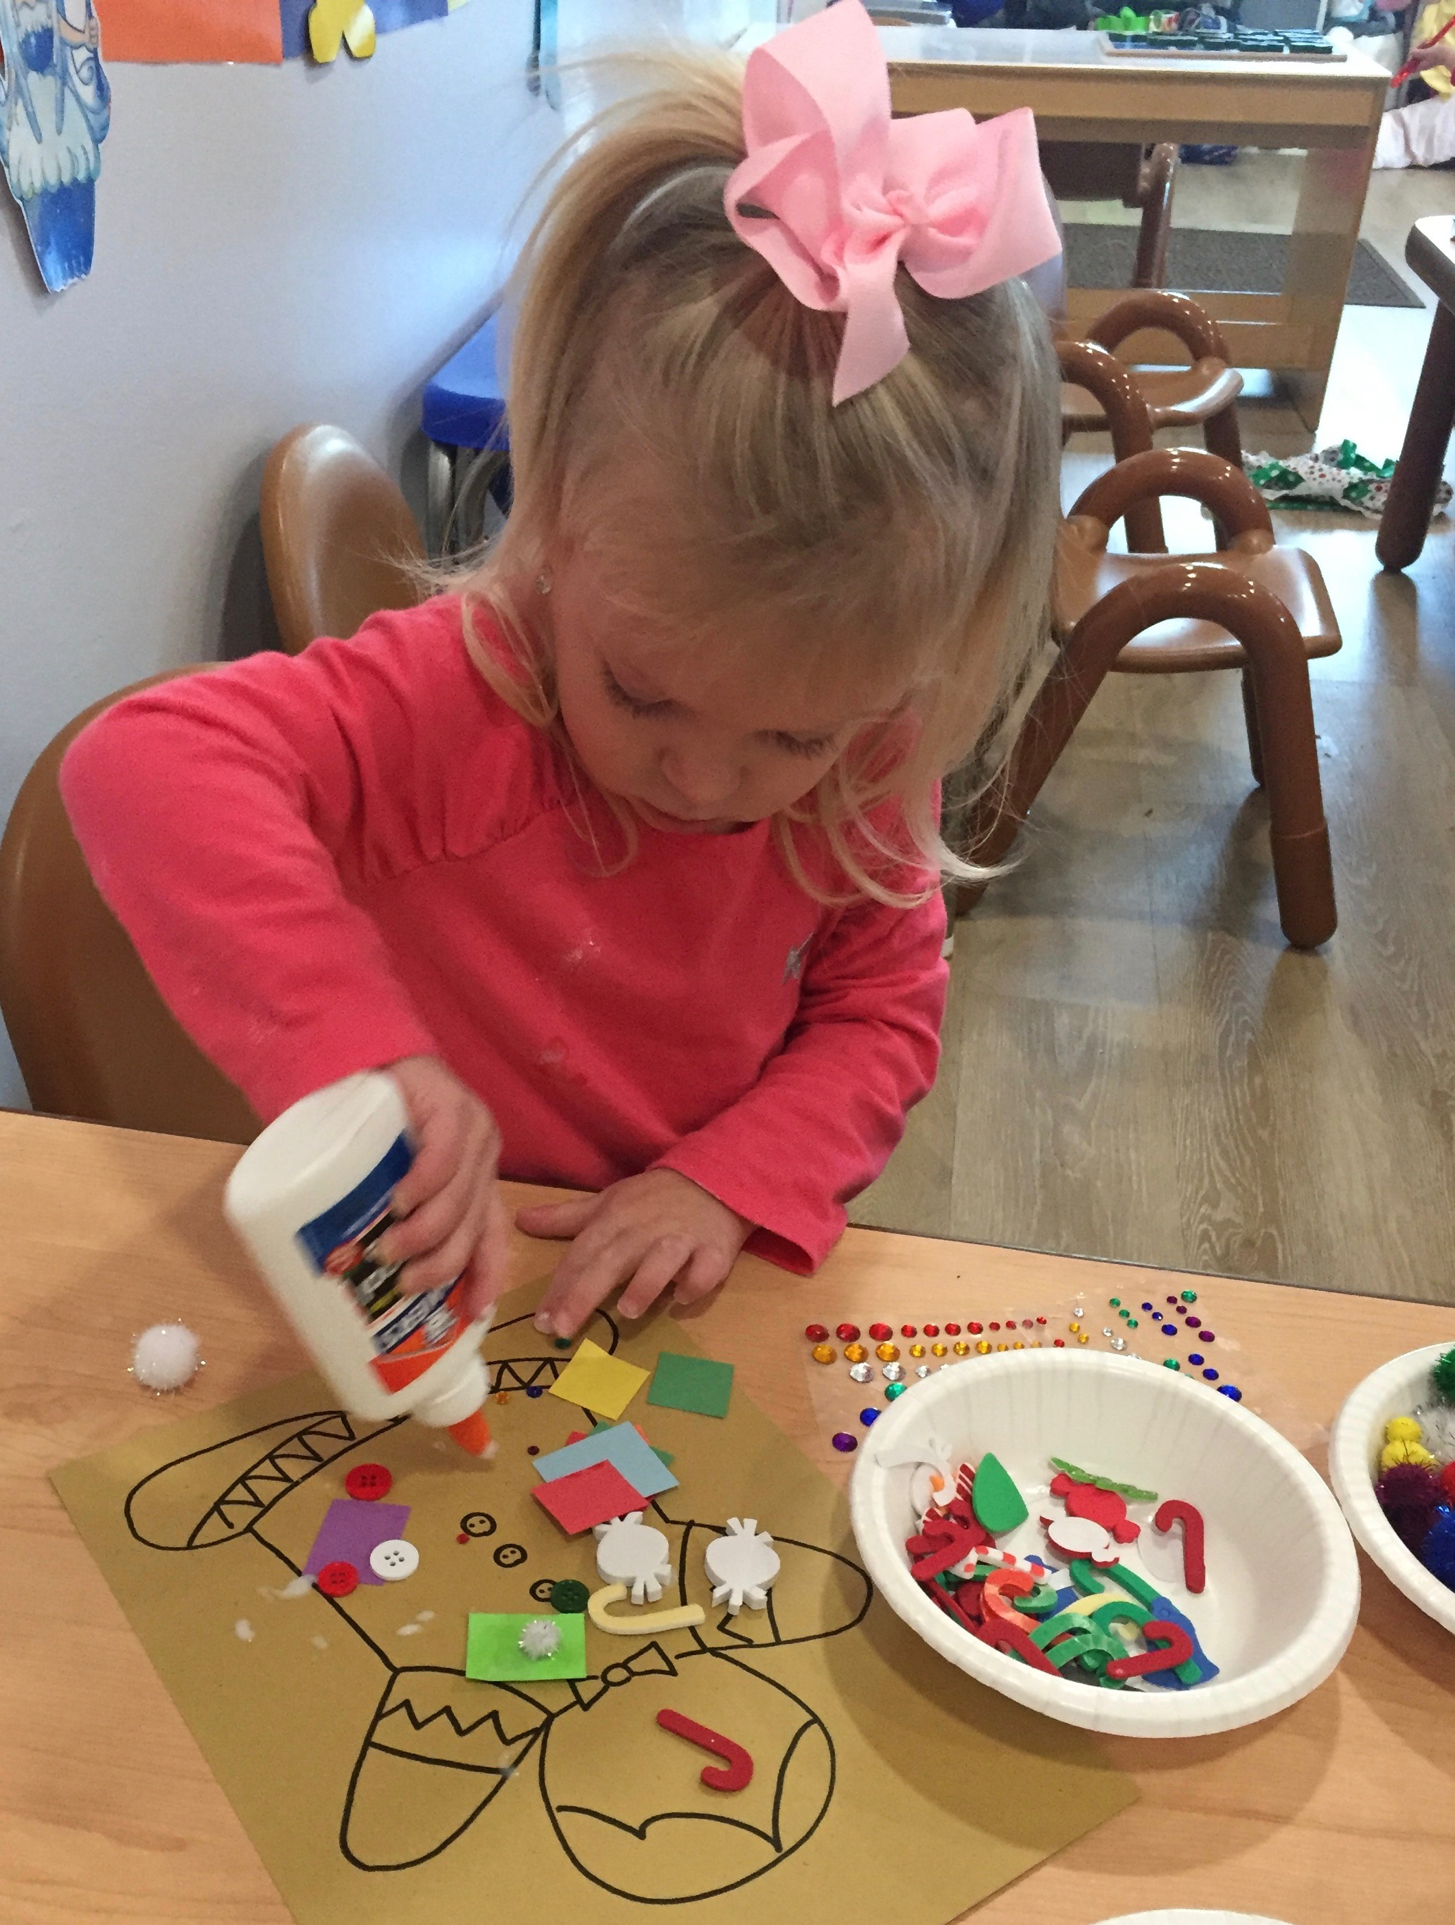
In our dramatic play area the children decorated our classroom tree with felt circle ornaments, which they created by filling them full of many different and colorful shapes.
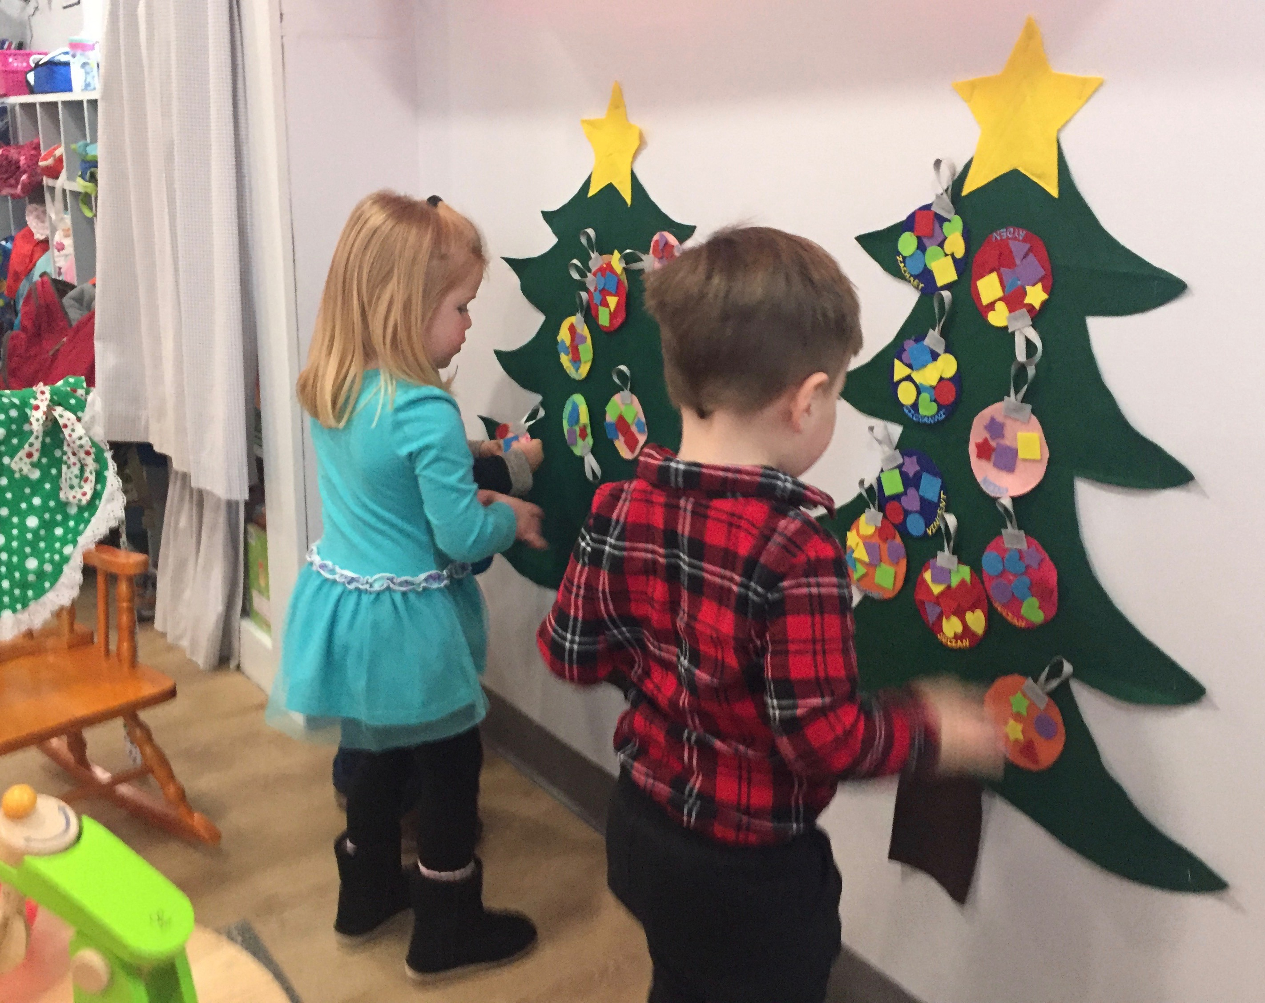

In the kitchen area the children worked hard to make yummy cupcakes and cookies. The children liked pretending that they were hot and needed to cool down. The spatulas became a novelty, as they loved using them to get the cookies and cupcakes off the baking sheet.
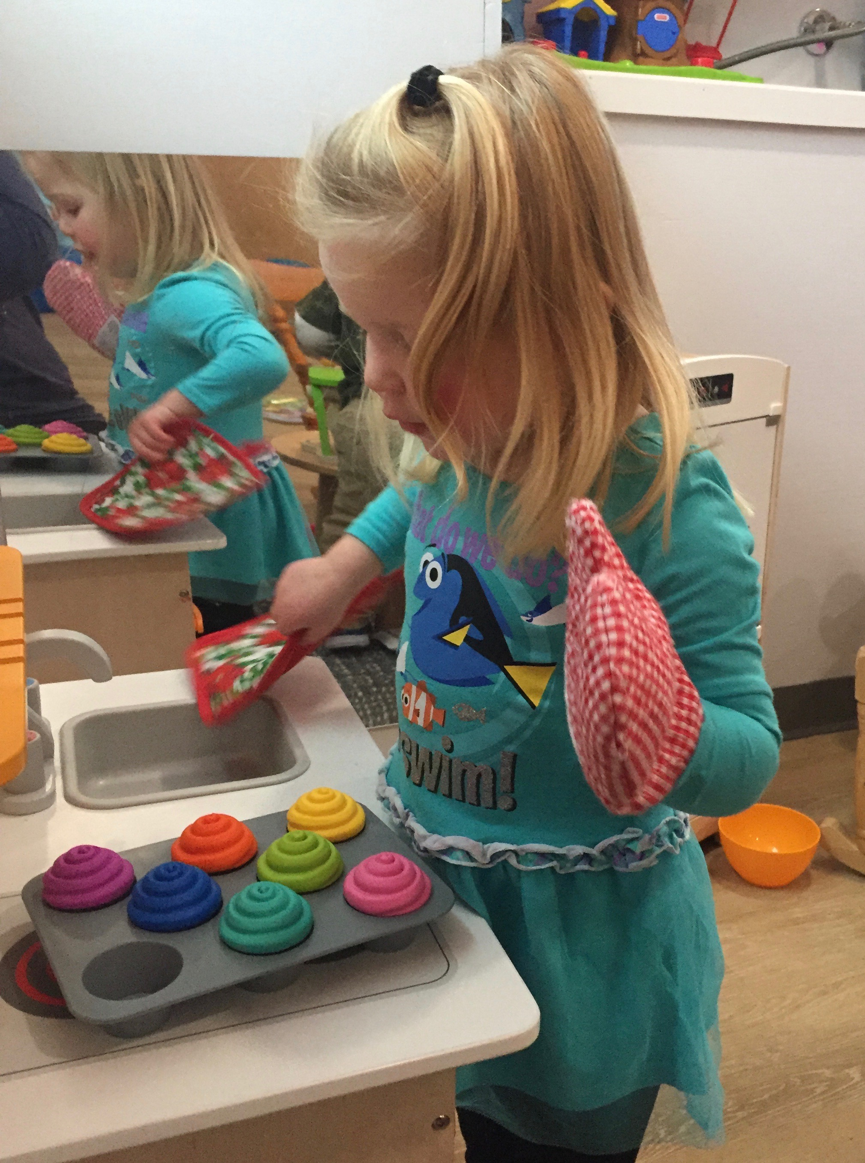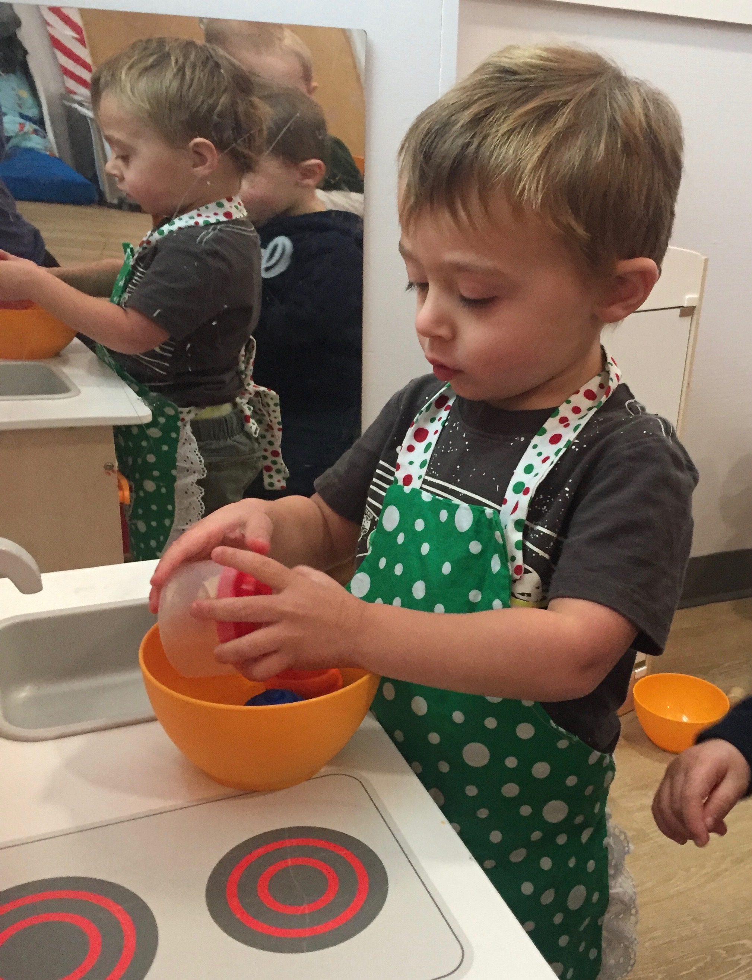
Mr. Moose visited our classroom for two weeks and the children loved having him.
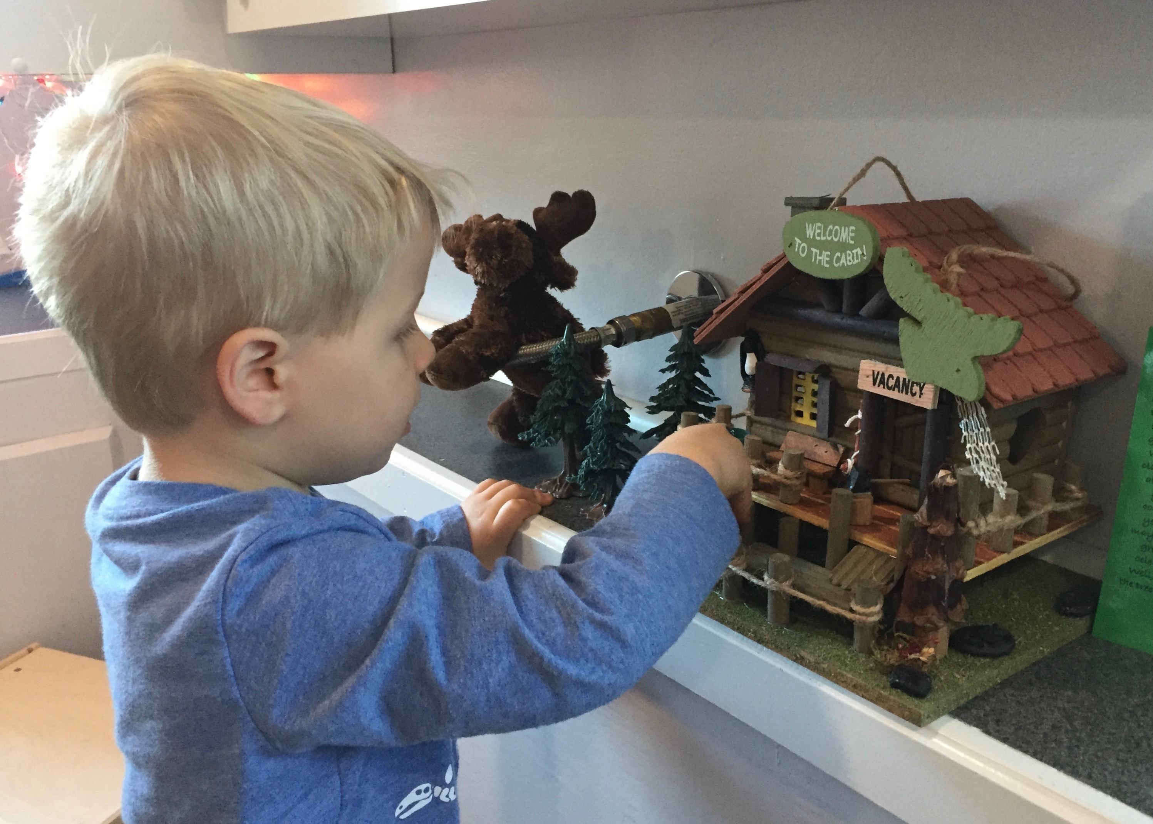
He helped them to learn the colors of the rainbow through his fun notes, silly adventures and color songs. He inspired color related crafts and activities while visiting.
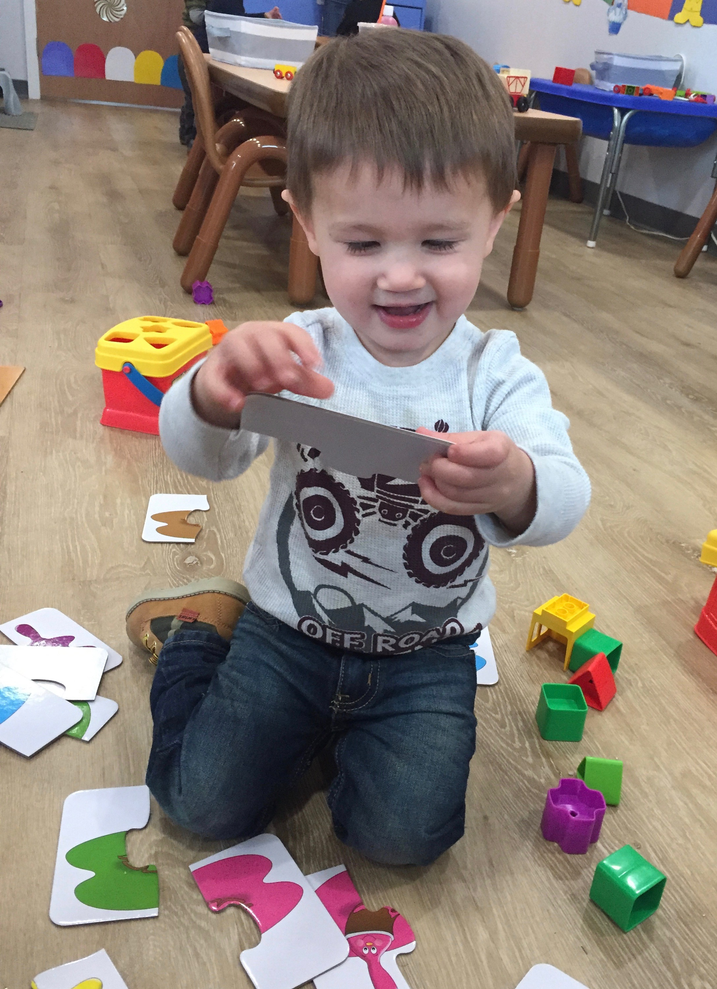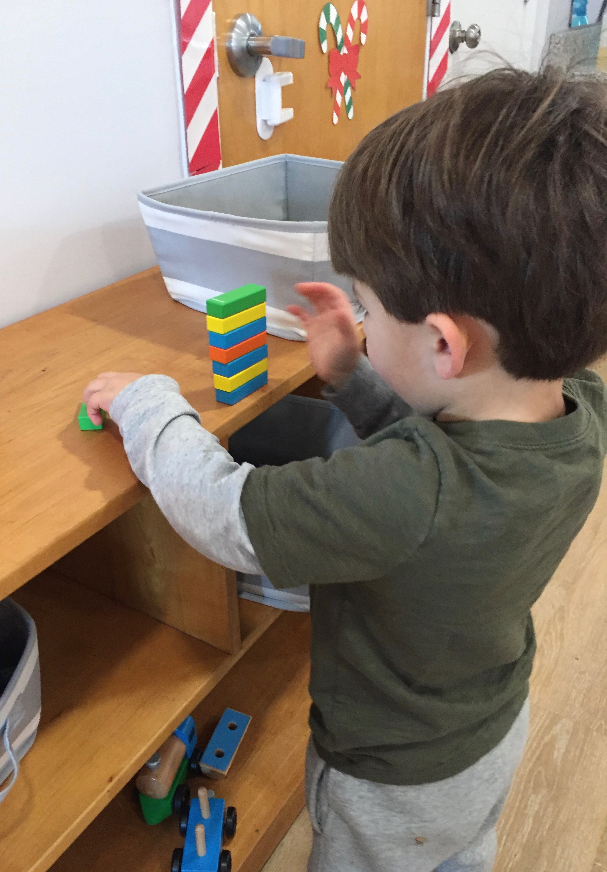

Mr. Moose had to head North for the holidays, but he left the children a surprise in the form of gingerbread shaped cookies. Everyone enjoyed decorating them with frosting and candy.
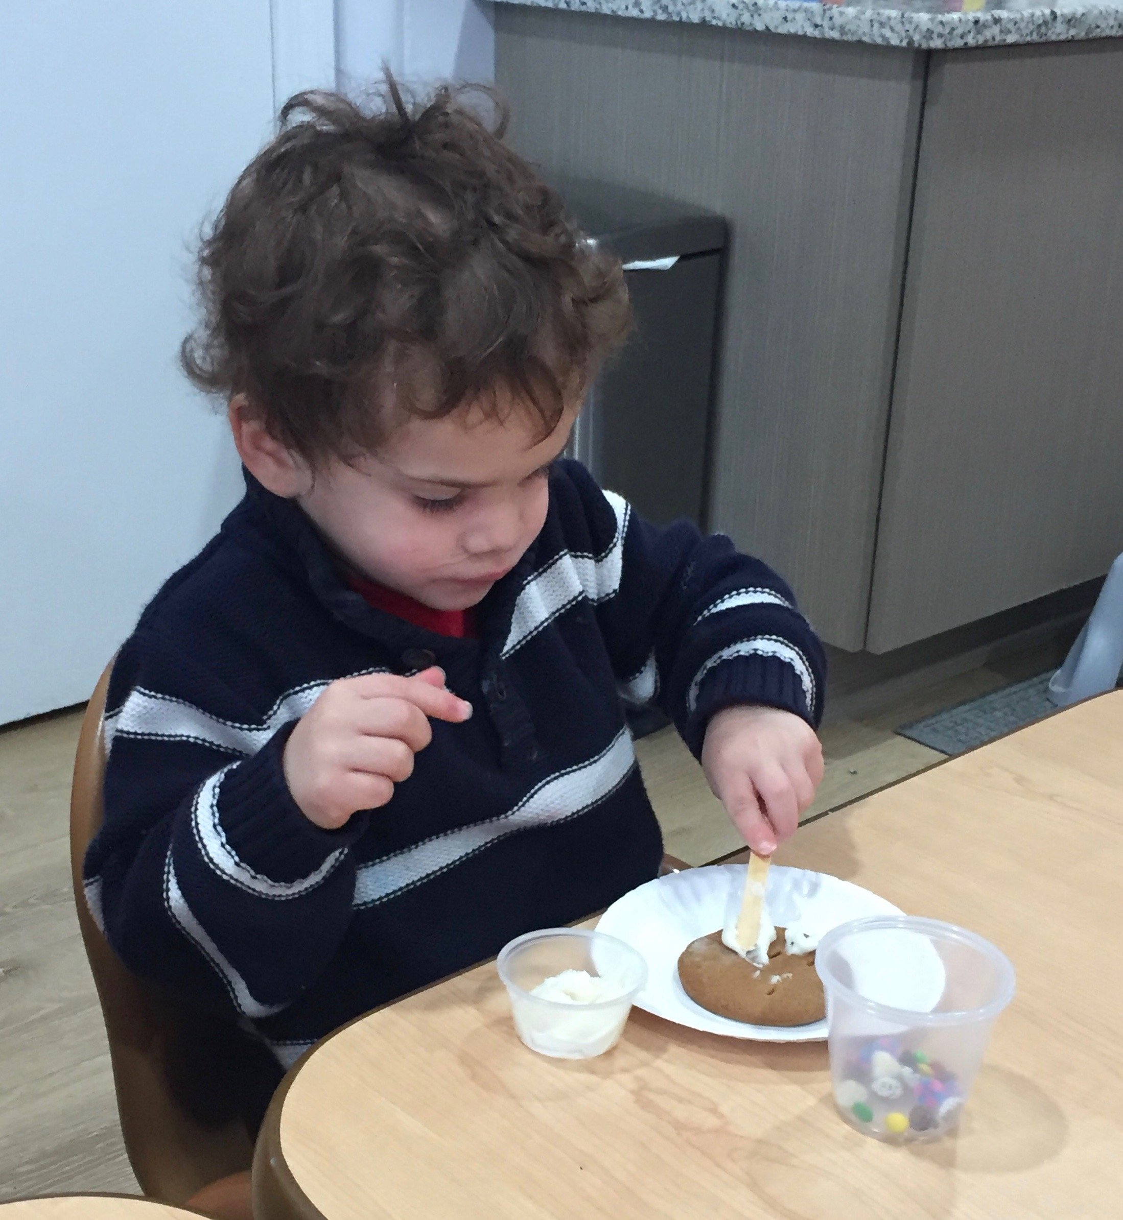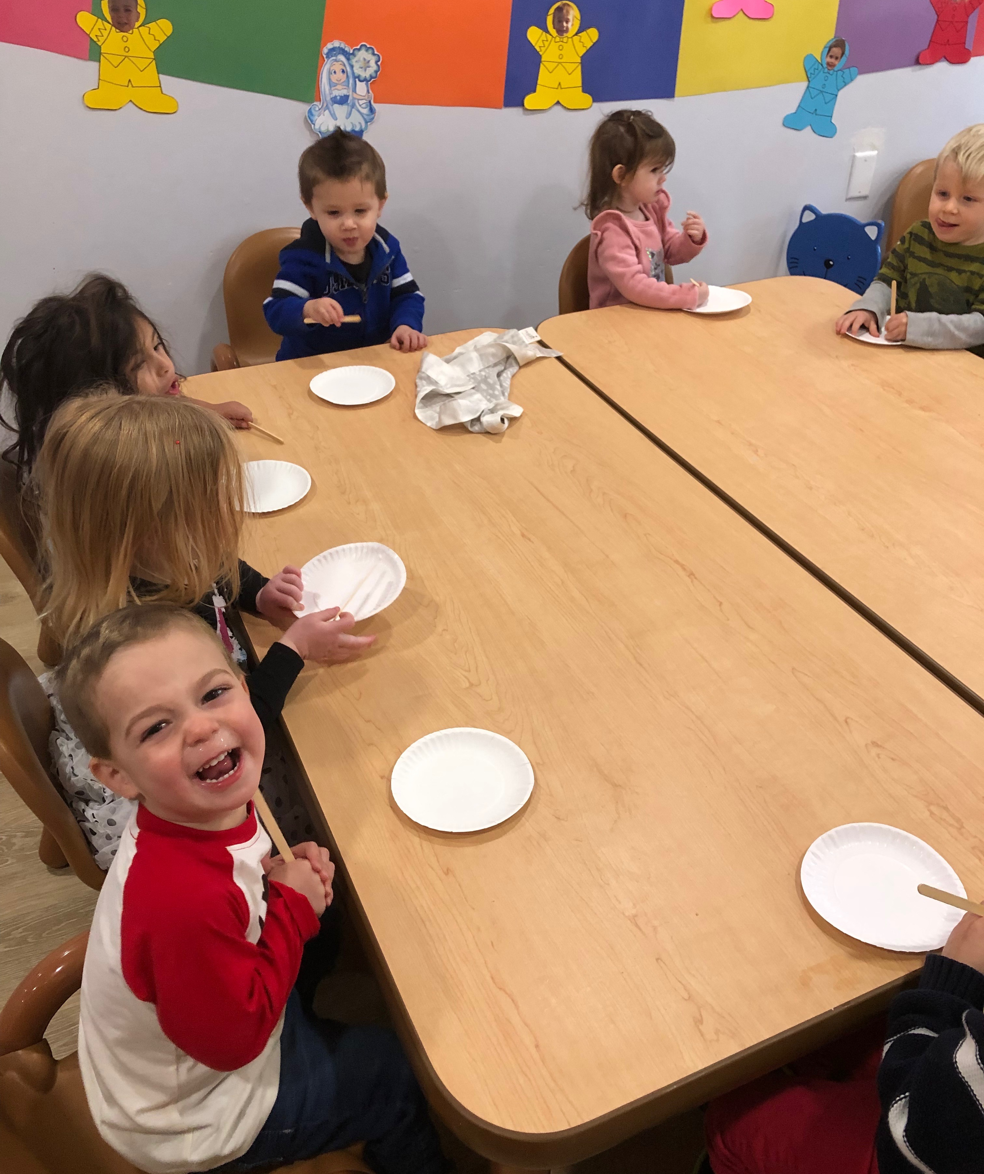

Winter Weather Advisory…
The children are enjoying our playground full of beautiful wet snow… but when they come in from outside play, their snow clothes can be very wet.
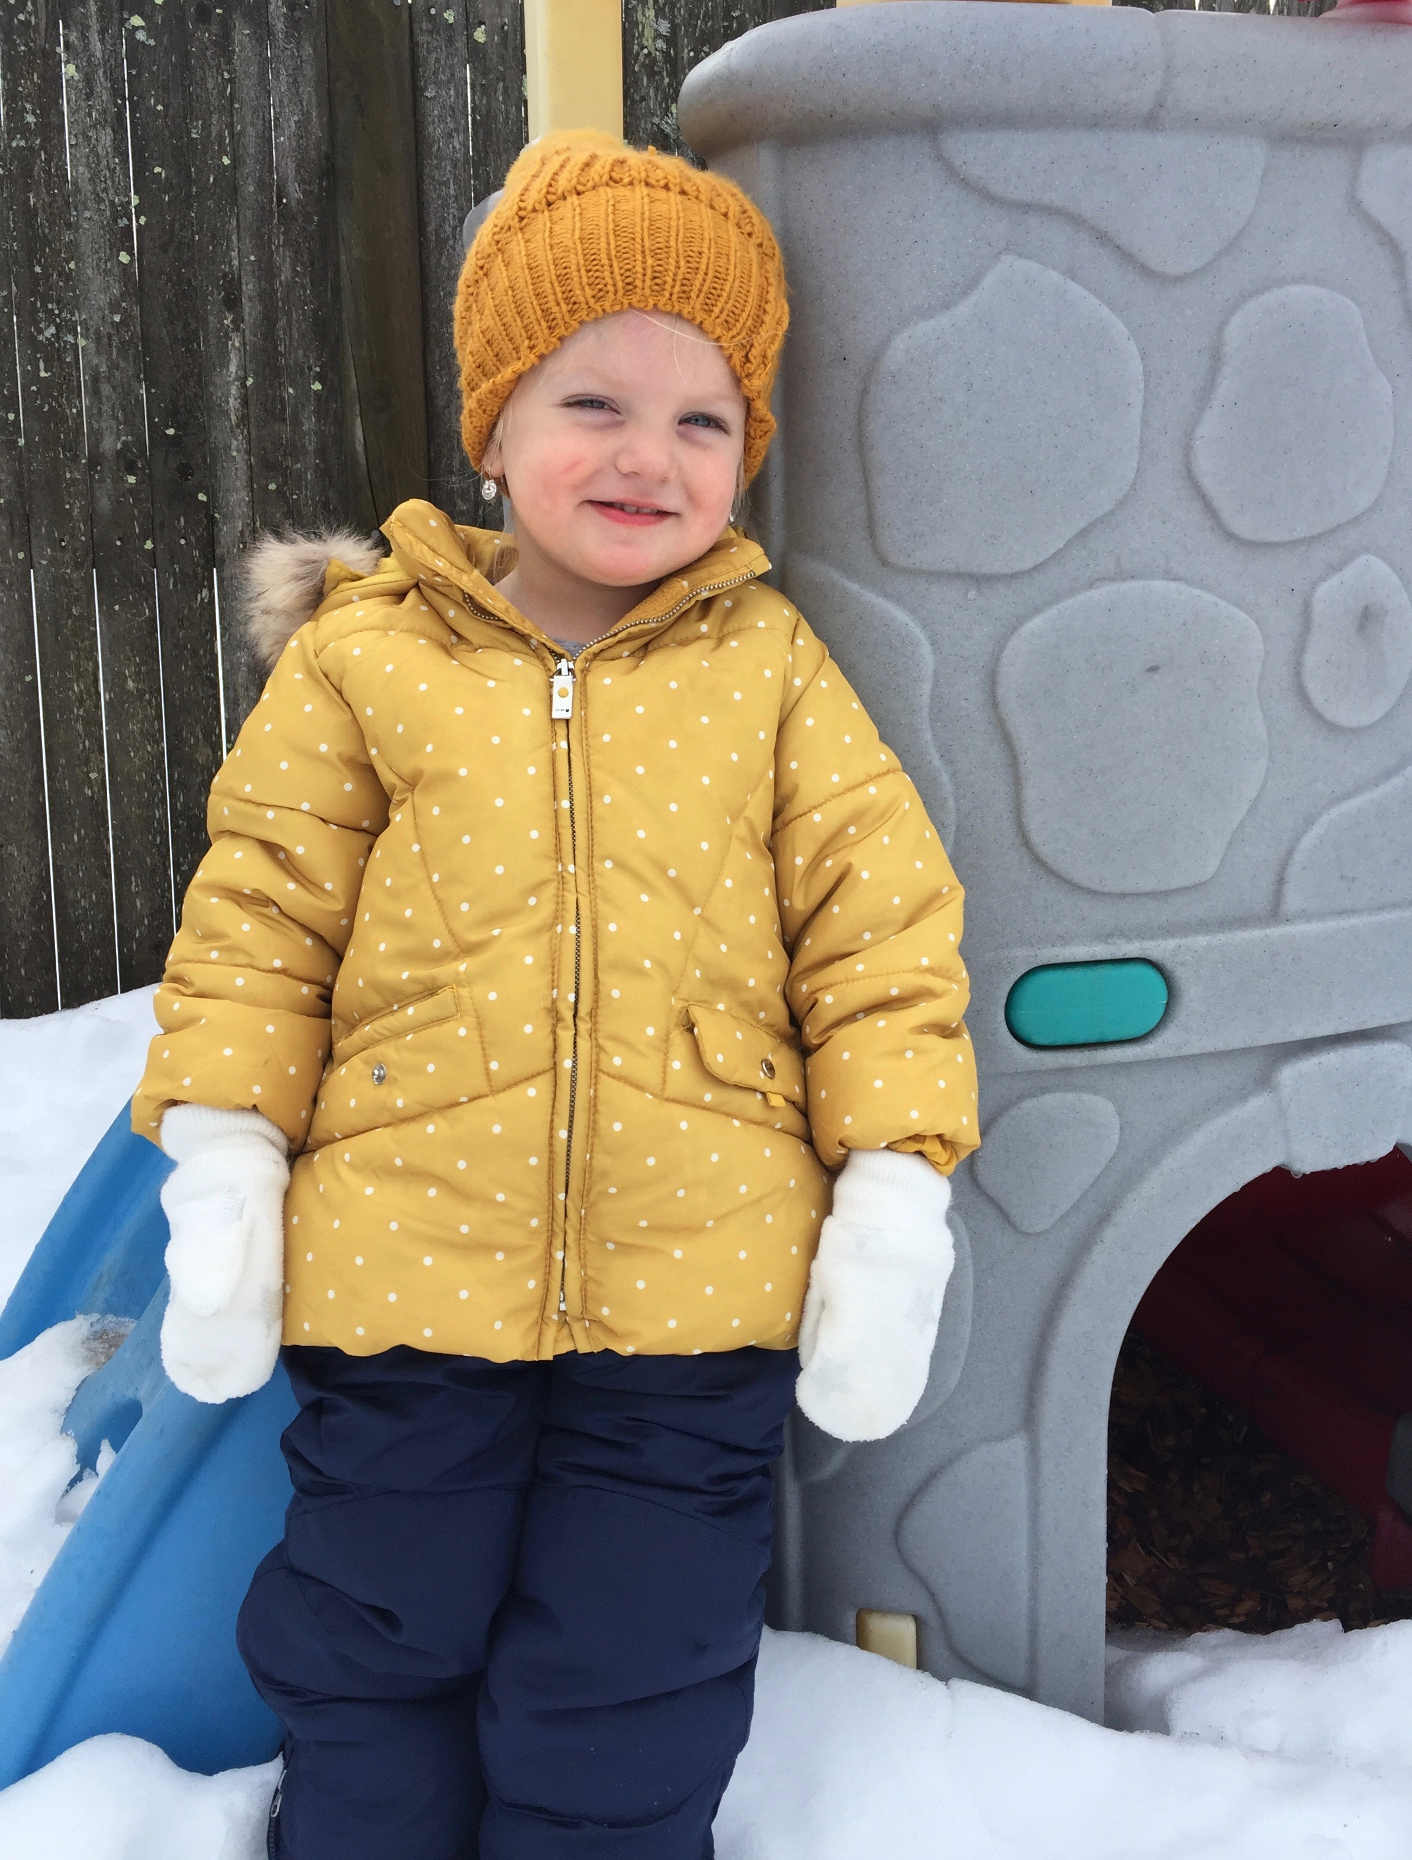
Please remember to empty your child’s bag each night and make sure all of your child’s snow gear is dry for the next day. Putting on wet snow gear can be very upsetting and uncomfortable for your child.

Self-help skills are an important part of your child’s development and learning. Our Early Learners are beginning to gain confidence in dressing themselves to go outside. We would like to encourage you to let your child dress him/herself in the home environment as well. It is wonderful to see the children feeling so proud of their accomplishment!

Your child’s portfolio is being sent home for you to look through over the holiday break. The portfolio tracks your child’s developmental growth throughout the school year. We hope you enjoy seeing your child learn and play in our classroom. Please return the portfolio to us in January so we can continue to add to it.
Happy Holidays and See you in the New Year!
Ms. Laura and Ms. Allison

