PRE-K 2 SNACK CALENDAR
November
Sun | Mon | Tue | Wed | Thu | Fri | Sat
 |  |  |  |  | 1
Mrs.Kaylee
&
LUKE
3 | 4 | 5 | 6 | 7 | 8 | 9
 | PAISLEY  &  SAYWER W | MADISON | AUBREE | KELLAN | TEIGAN
10 | 11 | 12 | 13 | 14 | 15 | 16
 |  | BRYSEN | HARRISON  &  LILLY | GREYSEN | SAWYWER V
17 | 18  ISABEL | 19  TESS | 20  DYLAN | 21  BRENDAN | 22  MACI  JADE | 23
24 | 25  Pre-K Lunch | 26  Pre-K Lunch | 27  EXTENDED  ONLY | 28  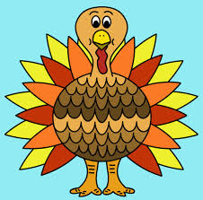 | 29  ELCM  CLOSED | 30
Theme: Harvest, Pumpkins, Family, Friends and Sharing

Show & Tell: We are asking for 2 photos – 4x6 of your child as a baby and any size
photo of your family. We will be creating a “Guess Who” book with the baby photos and
a “Pre-K Family Tree” for our display wall. If possible, please send a copy of the photos,
or email to Mrs.Kaylee your photos and she will print them out for our book & tree. ~Thank you~

